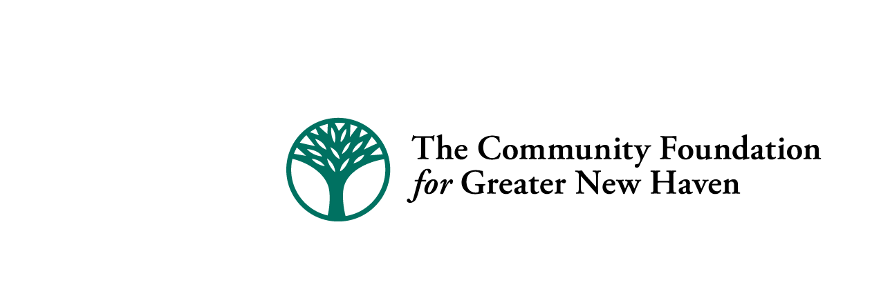

Quinnipiac River Fund Final Report- 2014

Please complete and submit completed form via e-mail to dcanning@cfgnh.org at The Community Foundation for Greater New Haven by March 30, 2015.

Date: _March 30, 2015__________________________

Group/Organization Name: _River Advocates of South Central CT (listed in application as “River Advocates of Greater New Haven”)______________________________________________________

Address: _c/o Martin Mador_____________________________________________________________________

City, State, & Zip: __130 Highland Ave., Hamden, CT 06518____________________________________________________________

Telephone #: __203-281-4326____________________________________

Project Name: _Lower Quinnipiac Advocacy_________________________________________________________________

Grant Number: _20140147_____________________

Name & title of person completing this form: _Mary Mushinsky, project consultant________________________________________

E-mail address: _marymushinsky@att.net______________________________________________

Please respond to the following statements:

- List the specific objectives/outcomes of the project and tell how they were met during the grant period. Also, provide an update on any special conditions of the grant (if applicable).

Description: To support increasing capacity of the organization, sponsoring public events to focus attention on the lower Quinnipiac and urban rivers of Greater New Haven, and implementing certain recommendations from the Urban River Permits Project to reduce polluted runoff.
Outcomes are listed below.

- Please share your successes, challenges and any lessons learned through the implementation of your project. Were there any unintended consequences or lessons learned that may affect how you operate your program moving forward?

River Advocates assembled a board of directors, had its initial meeting and applied for 501c3 non-profit status. The City of New Haven failed to follow through on their offer to allow certification and use of the city’s boats, so River Advocates pursued funding to acquire our own boats and storage facility. This gives us the ability to offer public paddle trips whether weekday or weekend, including the Quinnipiac Festival.

We offered osprey viewing at the West River Festival. River Advocates worked in partnership with The Sound School to refurbish the bird-watching blind at Quinnipiac Meadows (New Haven Land Trust). We joined with Wallingford’s Quinnipiac River Linear Trail Committee and North Haven Trails to sponsor fall marsh trail and spring wildflower hikes in North Haven and Quinnipiac River State Park.

We met with CT DEEP to review municipal land use survey results and create a way to respond to the municipalities’ common request for stormwater training to meet the MS4 requirements of the Clean Water Act. This is a follow-up to our report, Urban River Permits and Advocacy Recommendations for the Quinnipiac, Mill and West Rivers. We began monitoring the Water Utility Coordinating Committee for our region, to monitor diversion policy.

- What are the opportunities and needs of your organization as it continues to move forward with its work to positively impact the Quinnipiac River?

We are active participants in other coalitions and organizations interested in urban water quality and public access to rivers and are exchanging information and strategies with them. River Advocates continues to operate temporarily under our fiscal agent, Mill River Watershed Association. We are looking to share low or no-cost office space with existing regional organizations and are seeking to recruit interns.

Also, please include a photo or image that can be uploaded along with your report to The Quinnipiac River Fund website.

(photo: River Advocates worked with The Sound School to refurbish the bird watchers’ blind at Quinnipiac Meadows)

