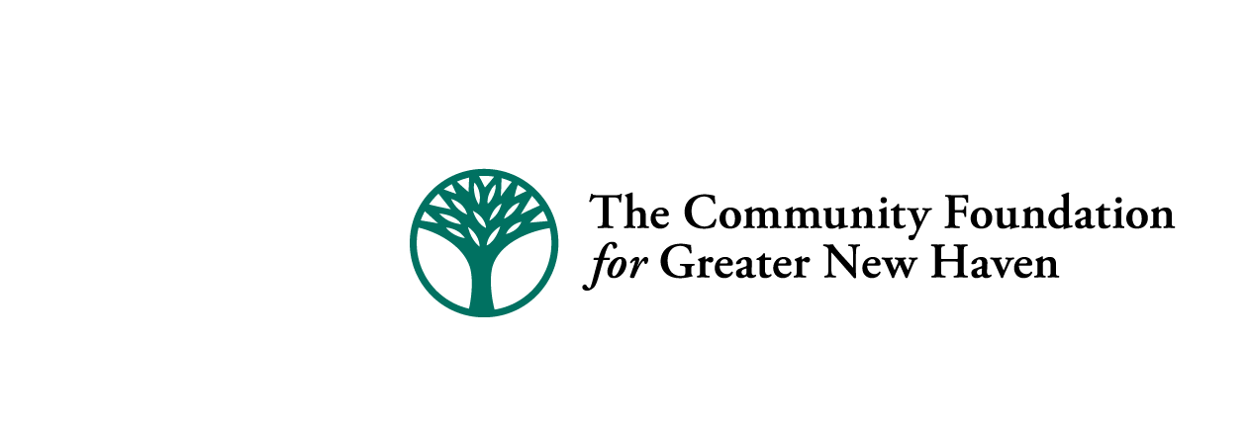

Quinnipiac River Fund Final Report- 2015

Please complete and submit completed form via e-mail to dcanning@cfgnh.org at The Community Foundation for Greater New Haven by March 30, 2016.

Date: _March 30, 2016_________________________

Group/Organization Name: __River Advocates of South Central CT (award document reads “River Advocates of Greater New Haven”)_____________________________________________________

Address: _Cordalie Benoit_c/o Martin Mador, 130 Highland Avenue____________________________________________________________________

City, State, & Zip: _Hamden, CT 06518_____________________________________________________________

Telephone #: _203-281-4326_____________________________________

Project Name: _Stormwater Training and Public Access_________________________________________________________________

Grant Number: _20150149_____________________

Name & title of person completing this form: __Mary Mushinsky, project consultant_______________________________________

E-mail address: _marymushinsky@att.net______________________________________________

Please respond to the following statements:

- List the specific objectives/outcomes of the project and tell how they were met during the grant period. Also, provide an update on any special conditions of the grant (if applicable).

To support training 3 municipal department of public works crews in stormwater pollution prevention using Lunch and Learn sessions and to support investigating the lower Quinnipiac River public access potential at two locations: Lowe's on Route 80 in New Haven and behind Toelles Road businesses in Wallingford, adjacent to Quinnipiac River State Park.

Outcomes are listed below.

- Please share your successes, challenges and any lessons learned through the implementation of your project. Were there any unintended consequences or lessons learned that may affect how you operate your program moving forward?

River Advocates assembled a Lunch and Learn presentation with the assistance of CT DEEP that covered multiple opportunities for town crews to help reduce stormwater pollution, including leaf removal, street sweeping, vegetative buffers and animal waste control. We included town-specific information on the amount of impervious cover and the state of river and stream impairment. We trained North Haven Dept. of Public Works, North Haven sewage treatment crew (at the request of North Haven), and health directors at their regional conference. There was an unexpected but welcome opportunity to coordinate with North Haven’s existing consultant, which resulted in adding the sewage treatment presentation. Crews were attentive and engaged in a dialogue regarding the best way to accomplish the recommended best practices.

We met with the City of New Haven to investigate the history of the Lowe’s coastal access and city plan permits, which concern access to the Little River, a Quinnipiac tributary. In addition, we contacted the owner of the L. Suzio Concrete Co. on Toelles Rd., Wallingford to investigate the possibility of access to the Quinnipiac River for water trail maintenance and public paddling access. Suzio granted access for water trail work crews, but preferred general public access visitors park outside their property along Toelles Rd.. Suzio cautioned that the Town of Wallingford holds a utilities easement near the road which will complicate efforts to create a safe parking space.

- What are the opportunities and needs of your organization as it continues to move forward with its work to positively impact the Quinnipiac River?

River Advocates obtained non-profit status in January 2016 and separated from our original fiscal agent, Mill River Watershed Association. The board changed the name to River Advocates of South Central Connecticut. We expect to expand our efforts on river protection and will seek low or no-cost office space to build our capacity. In 2015 we initiated an internship program with the assistance of Town of Wallingford Youth and Social Services and summer youth employment to assist with public events.

Also, please include a photo or image that can be uploaded along with your report to The Quinnipiac River Fund website.

(Photo: North Haven Dept. of Public Works employees listen to stormwater Lunch and Learn presentation in Oct. 2015.)

