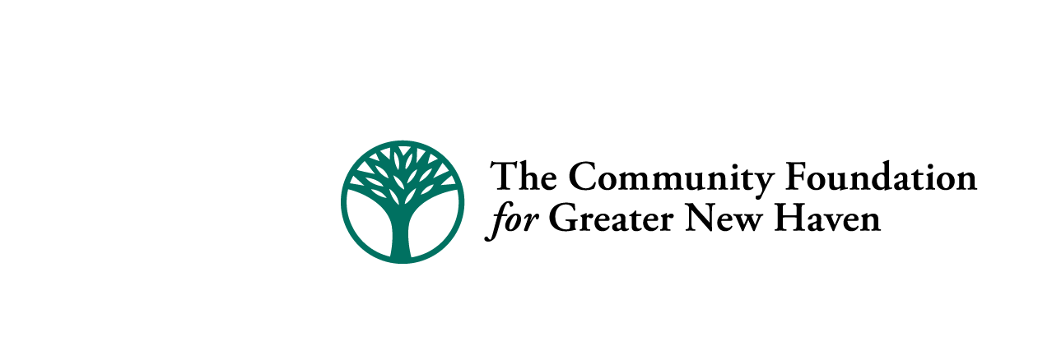

Quinnipiac River Fund Final Report- 2016

Please complete and submit completed form via e-mail to dcanning@cfgnh.org at The Community Foundation for Greater New Haven by March 30, 2017.

Date: _March 30, 2017_________________________

Group/Organization Name: __River Advocates of South Central CT_____________________________________________________

Address: __c/o 130 Highland Avenue____________________________________________________________________

City, State, & Zip: _Hamden, CT 06518_____________________________________________________________

Telephone #: __203-281-4326____________________________________

Project Name: _Lower Quinnipiac Protection_________________________________________________________________

Grant Number: _20160129_____________________

Name & title of person completing this form: _Mary Mushinsky-projects director________________________________________

E-mail address: _marymushinsky@att.net______________________________________________

Please respond to the following statements:

- List the specific objectives/outcomes of the project and tell how they were met during the grant period. Also, provide an update on any special conditions of the grant (if applicable).

to support Lunch and Learn sessions for municipal department of public works crews in the lower Quinnipiac watershed for best practices in stormwater pollution prevention; enforcement of public access at an abandoned, neglected Quinnipiac River site at Lowe's on Route 80 in New Haven; education of phosphorus control; and monitoring of pollution and diversion permits.

Outcomes are discussed below.

- Please share your successes, challenges and any lessons learned through the implementation of your project. Were there any unintended consequences or lessons learned that may affect how you operate your program moving forward?

Lunch and Learn sessions have now been completed for Wallingford Dept. of Public Works (DPW), North Haven Dept. of Public Works, North Haven Sewage Treatment Plant, and local departments of health at their regional conference. Because we collect feedback at the conclusion of each session, we learned which stormwater protection techniques are possible with the equipment and capabilities of each crew. We are seeking to bring the presentation to New Haven.

Crews are genuinely interested in improving water quality. We found that using the River Guides (high school interns) to co-teach was warmly received by the crews. On lessons learned, we were disappointed to find that AFTER our presentation, the Town of Wallingford hired a vendor to cut down the vegetative buffer around 1/3 of the shoreline of Community Lake, which connects to the Quinnipiac River. The hired crew followed the directive of the Town’s Park and Recreation Department even though it violated the Lunch and Learn training on protecting buffers. We learned it will be important to include Parks and Rec. in future stormwater training.

The City of New Haven Planning Dept. helped provide evidence of the original access requirement that accompanied Lowe’s permit. Lowe’s initially built the public access, but never touched the trail again and trees and shrubs quickly overtook it, lifting pavement and encouraging an abundance of ticks. The trail is impassible. We shared the permit requirement with Lowe’s and are working with the manager.

On phosphorus, municipal opponents challenged the science and requirements of phosphorus reduction but were rebuffed by US EPA. We recommended incentives and a funding timetable to promote cooperation among municipalities.

River Advocates intervened in an allnex (formerly Cytec) permit for an expanded product line that would introduce a new, unregulated toxin—tetrahydrofuran--into the company’s effluent. CT DEEP proposed the company simply monitor the new toxin. We objected, petitioned for a hearing, then negotiated to drop the hearing in exchange for setting a new standard (based on a Great Lakes standard) and an agreement to allow Quinnipiac University to enter the property to collect samples. CT Fund for the Environment accompanied us in the successful negotiation.

We organized and educated citizens for Streamflow classification comments on the impaired streams in our South Central Coastal River Basin region.

- What are the opportunities and needs of your organization as it continues to move forward with its work to positively impact the Quinnipiac River?

River Advocates has an opportunity to share expertise with other Greater New Haven clean water and neighborhood allies and help each other build public access and interest in river restoration. The River Guides (intern program) showcases young residents who live in the Quinnipiac basin and will be future leaders. Our new office space in a co-working building (Whitneyville Cultural Commons) provides room for larger meetings and training sessions.

Our organization should add at least one other part-time staff to carry out the projects, work with allies, generate additional creative funding sources and sponsors, help supervise River Guides and fund our co-working office space after the in-kind offer of space ends.

Also, please include a photo or image that can be uploaded along with your report to The Quinnipiac River Fund website.

(photos: Wallingford Dept. of Public Works crew listens to stormwater slide presentation by River Advocates interns in September 2016)

